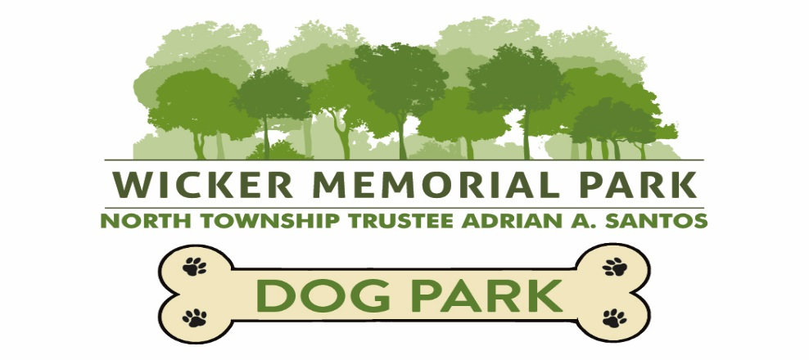

**WICKER MEMORIAL PARK DOG PARK 2025**

**ACKNOWLEDGMENT, WAIVER AND RELEASE FROM LIABILITY**

I, , DO HEREBY RELEASE AND DISCHARGE from any and all claims, losses, death, personal injury, partial or permanent disability, property damage, medical or hospital bills, theft or damage of any kind, including economic loss which may arise out of or be related to my dog or myself using and/or participating in any and all activities associated with the use of the Wicker Memorial Park Dog Park including **the following persons or entities: Lake County, North Township, any and all employees of Wicker Memorial Park and/or North Township, the North Township Trustee, North Township Board members and any agents thereof even if such claims, losses or liabilities that were caused by the negligent acts or omissions of these persons that I am hereby releasing or are caused by the negligent acts or omissions of other persons or entities, I am further assuming any and/or all risks associated with the Dog Park at Wicker Memorial Park, and I further acknowledge that there are risks associated Dog Parks including the risk of serious injury and death to the dog, dog owner and other persons using the Dog Park while on the property of Wicker Memorial Park that may result from my negligence, my dog’s negligence and/or negligence of the persons or entities above-mentioned herein.** I further acknowledge that I am at least eighteen (18) years of age and that I am the legal owner of the dog participating in the Dog Park and read the above acknowledgement, waiver and release from liability.

Date Signature